**Mailgun Setup**

1. Create an account in mailgun website. Visit this <https://signup.mailgun.com/new/signup> link.
2. Fill in the required fields. The signup page looks like as shown below:

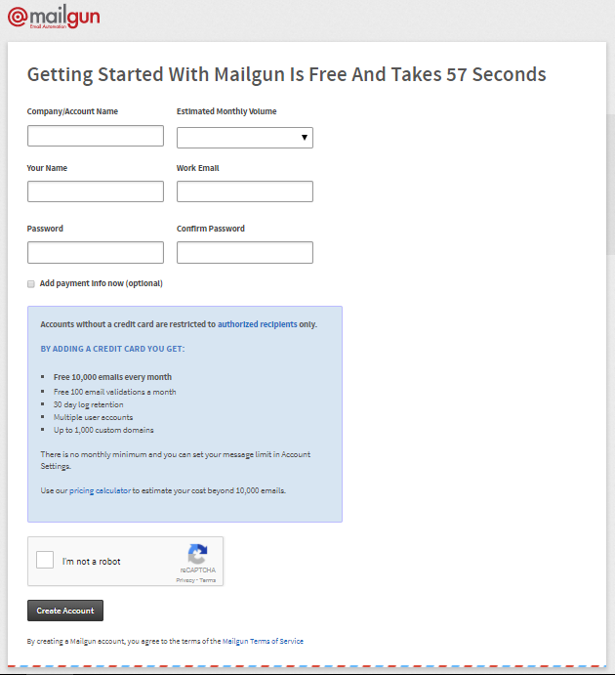

1. After creating account a verification mail will be sent to the registered email.
2. Click on the verification link to verify your account.
3. After the verification part is done login to your mailgun account. The login link is <https://app.mailgun.com/sessions/new>
4. After logging in the mailgun dashboard appears as bellow :

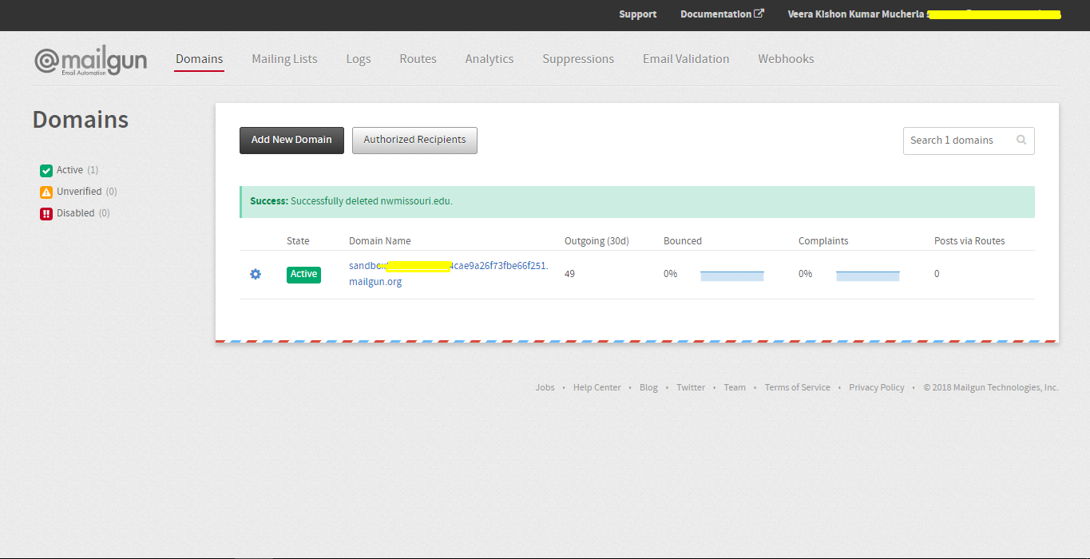

1. A domain will be created by default. If you don’t want the default domain you can create one by clicking on the “Add New Domain” button.
2. Update the domain and API key in constants file.
3. To send emails to a user you have to add that user’s mail id to the recipients list by clicking on “Authorized Recipients” button.

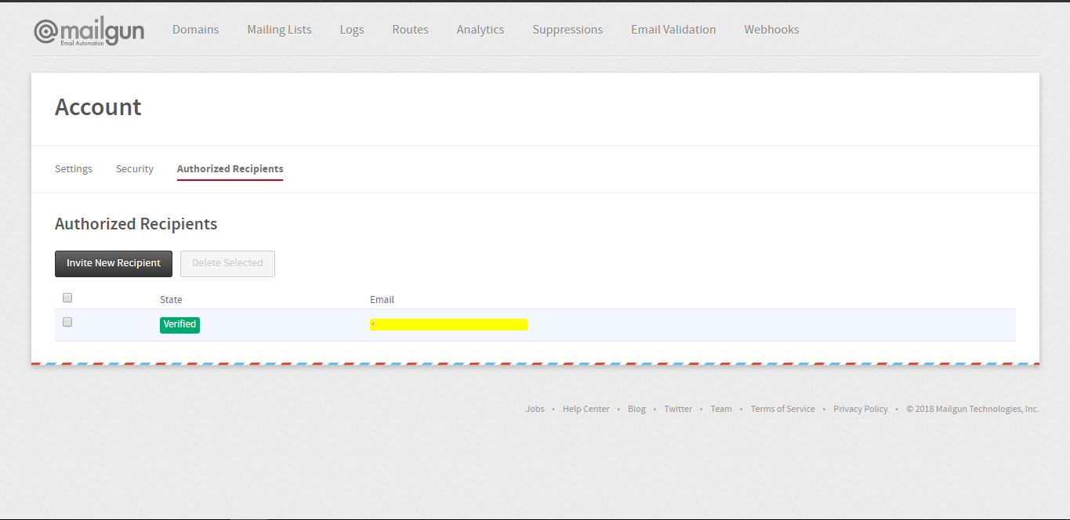

1. A verification mail will be sent to the recipient who was added to the recipients list.
2. After the recipients verification is done, then you are all set to go.